Erasmus + project: Young Citizens of Europe – Our Future

Meeting in Craiova, Romania, 08.- 14. 11 2015.

Romanian lessson
Date: 8th November 2015
School: Liceul de Arte „ Marin Sorescu”, Craiova
Teacher: Mirea Ileana
Level: beginner
Type of lesson: Acquiring new knowledge- vocabulary and grammar structures; use vocabulary in context
Competences:
- to teach students and teachers some basic words and phrases.
- learn greetings in Romanian language
- learn how to introduce oneself
- acquire key vocabulary to talk about weather, food, hotels and restaurants
- practice vocabulary in context.
Skills: speaking, writing, reading
Aims:
- students and teachers will get used to some basic Romanian words and phrases and use them in context.
- students and teachers will be able to introduce themselves in Romanian language
- students and teachers will be able to greet someone in Romanian
- students and teachers will be able to acquire vocabulary and structures concerning the following topics: personal details(name, age, job, city, country); greetings, introducing people, numbers, colors, days of the week, months of the year, seasons, weather, food, hotels and restaurants.
Aids: handouts, worksheets, ppt, picture cards
Bibliography:
- Vocabulary in Action- Auxiliary material, Mirea Ileana, Craiova, 2011.
ORGANISATON – Individual work, pair work and group work
Notice: Both Ss and teachers will be referred to as Ss.
Assumed knowledge: Ss are not familiar with any of the structures introduced
Techniques: brainstorming, discussion, exercise, explanation, learning by discovering.
Materials: picture cards, handouts, Ppt.
Classroom management: frontal, individual, pair work
Anticipated problems: the students will not pronounce correctly some words; they will make mistakes in word order, accent, pace, fluency, accuracy etc.
Time: 50 minutes
CONTENTS:

Activity 1: presentation; introduction
TIMING: 2 minutes
Skills: Speaking, reading
Class Organization: T- Ss
Procedure: Students listen to the teacher who introduces herself and greets the audience, helped by her student assistants. They learn to say „ Bine ati venit in Romania”- „Welcome to Romania”while the assistants move around the classrooms offering small souvenirs – bookmarks with traditional motifs.

Activity 2: practicing greetings
TIMING : 3 minutes
Skills: speaking
Class Organization: T- Ss, pair work,
Procedure: Teacher points to some slides containing pictures, emphasizing the basic greetings in Romanaian: Teacher prounounces slowly each greeting asking the students to repeat each greeting according to the worksheet and ppt. The assistants also practice in pairs each greeting. Students repeat as a whole classroom, in pairs and individually. They are then given pairs of picture cards with the same pictures from the ppt and they are asked to find their pair and greet each other. Ss perform the task.
AIM: To focus their attention on greetings; to practice greetings in Romanian.

Activity 3: introducing people
TIMING – 5 minutes
Skills: Reading, Speaking
Class Organization: T- Ss
Procedure: The teacher will ask the students to repeat the following words and phrases in order to
learn how to ask and answer to indroduce themselves or the others.
Eu! I!; Tu! You!; He ! El!; Ea! She! POLONIA -POLAND; TURCIA -TURKEY; ITALIA-
ITALY;CROAȚIA-CROATIA;FINLANDA-FINLAND;BULGARIA –BULGARIA;ROMÂNIA -ROMANIA
Cum te numesti? What’s your name?
Numele meu este….. My name is …….
Where are you from? De unde esti?
Eu sunt din ……… I’m from ……………
AIM – To determine students to use set structures to introduce themselves and the others ( personal
pronouns, native countries, „What’s your name? My name is....Where are you from...? I’m from.....SS
practice in pairs and individually, The assistants offer their own model of introducing people.

Activity 4: expressing age using numbers
Skills: Reading, Speaking
TIMING – 5 minutes
Class Organization: T- Ss,individual,pairwork
Procedure: the teacher helps Ss to learn numbers by modelling and repeating until Ss are confident
enough to use them to express their age ( How old are you?- cati ani ai? I’m ......years old – eu am
....ani)
1.-unu; 2-doi ; 3-trei; 4-patru; 5-cinci;6-șase;7-șapte;8-opt; 9-nouă;10-zece.
CAȚI ANI AI? HOW OLD ARE YOU?
EU AM ..... ANI. I AM.....YEARS OLD.
AIM –to talk about age using numbers.

Activity 5: asking and answering about what someone is/job
TIMING – 5 minutes
Skills: Reading, Speaking
Class Organization: T- Ss; SS- SS
Procedure : Controlled Practice
T. introduces the question „ What are you?- ce esti tu? and elicits answers : Eu sunt elev/eleva /
profesor/ profesoara
AIM – To encourage students to use the structures above

Activity 6: progress check
TIMING – 5 minutes
Skills: speaking, writing.
Procedure: T. asks Ss. to complete their own identity card using all the structures acquired so far, as
in the example. T explains that SS have to ask the right question, so that the answer should be that
written on the ID. Ss design the ID and then practice in pairs by asking and answering using the
structures introduced before. Ex:Cum te numesti?- What’s your name?; Eu ma numesc........-My name
is ....,etc.)

ELEV/ELEVĂ
ILEANA 41
PROFESOR/PROFESOARĂ
CRAIOVA-ROMANIA

Activity 7: Colours
TIMIMG: 5 minutes
Skills: Reading , speaking
Class Organization: T- Ss, whole class
Procedure: Teacher points to the colours on the slide that show up each at its turn and elicits answers. Ss answer accordingly. T then shows a suggestive picture acc. to the ppt. each in connection with a certain colours( ex. „Sun” to elicit „yellow”- „soare-„ pentru „ galben” etc).
AIM: to learn colours.

Activity 8: The days of the week, ; The months of the year; the seasons
TIMIMG: 5 minutes
Skills: Reading , speaking
Class Organization: T- Ss, whole class
Procedure: Teacher introduces the days of the week insisting on correct Romanian pronounciation. T asks Ss to match each day of the week with the corresponding project activity for the unfolding week. Ss answer.
T. then introduces the months of the year and the four seasons asking Ss to match each season with the corresponding months . SS match.
AIM: to learn the days of the week, the months of the year; the seasons.

Activity 9: Weather collocations
TIMIMG: 5 minutes
Skills: Reading , speaking
Class Organization: T- Ss, whole class
Procedure: Teacher points to some pictures on the slide that have to be matched to some weather realated phrases. Ss answer.T also introduces the phrase „ What’s the weather like” ;” Cum este vremea”-( see slide 51-57)
AIM: to acquire weather- related phrases.

Activity10: Meals of the day; Food
TIMIMG: 5 minutes
Skills: Reading , speaking
Class Organization: T- Ss, whole class
Procedure: Teacher points to some pictures on the slide containing traditional dishes and asks Ss to repeat after her. Ss answer. T then asks Ss to fill in some blanks with the missing „ food” words and phrases . Ss answer. T assists Ss to give correct answers. (see slide 58 and 61)
AIM: to learn meals of the day and food phrases.

Activity11: Assigning homework/Hotel and restaurant phrases
TIMIMG: 5 minutes
Skills: Reading , speaking
Class Organization: T- Ss, whole class
Procedure: Teacher points to some phrases on the sliderelated to hotels and restaurants vocabulary. T explains that Ss will have to put the phrases in the right order to obtain correct dialogues at the hotel or restauran ( see slide 64 and 65). Ss will usetheir worksheets to do their homework)
AIM: to learn hotel/restaurant phrases in Romanian.

Worksheet

WELCOME!!!!
Romanian English
Bine ați venit în România! Welcome to Romania!
Bine ați venit în Craiova! Welcome to Craiova!
Bine ați venit în Liceul de Arte “Marin Sorescu” Welcome to “ Marin Sorescu” High School of Arts!
Saluturi!!!-GREETINGS AND FAREWELLS!!!
Buna dimineața! Good morning!
Buna ziua! Good afternoon!
Buna seara! Good evening
Noapte buna! Good night!
Salut! Bună! Hi! Hello!
La revedere! Good bye!
Eu ! I!
Tu! You!
El! He!
Ea! She!
POLONIA POLAND
TURCIA TURKEY
ITALIA ITALY
CROAȚIA CROATIA
FINLANDA FINLAND
BULGARIA BULGARIA
ROMÂNIA ROMANIA
Cum te numesti? What’s your name?
Numele meu este….. My name is …….
Where are you from? De unde esti?
Eu sunt din ……… I’m from ……………
NUMERELE... NUMBERS...
1.-unu; 2-doi ; 3-trei; 4-patru; 5-cinci;6-șase;7-șapte;8-opt; 9-nouă;10-zece.
CAȚI ANI AI? HOW OLD ARE YOU?
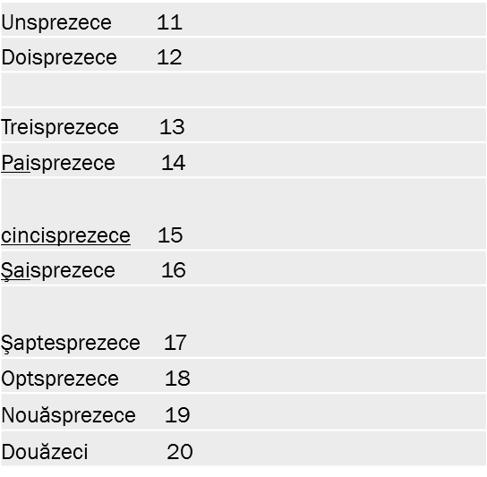
EU AM ..... ANI. I AM.....YEARS OLD.
21/douăzeci şi unu
22/douăzeci şi doi
23/douăzeci şi trei
24/douăzeci şi patru
25/douăzeci şi cinci
26/douăzeci şi şase
27/douăzeci şi şapte
28/douăzeci şi opt
29/douăzeci şi nouă
30/treizeci
40/patruzeci
50/cincizeci ; 60/şaizeci; 70/şaptezeci
CE EȘTI TU? WHAT ARE YOU?
EU SUNT PROFESOR/PROFESOARA/ELEV(Ă) I AM A TEACHER/ A STUDENT .

CULORI/COLOURS
Roșu- red; Galben –yellow; Roz -pink ;Verde –green; Albastru-blue; Gri –grey; Negru -black ;Maro-brown; Mov -purple ; Portocaliu -orange ; Alb -white.

ZILELE SĂPTĂMÂNII! THE DAYS OF THE WEEK!
Luni- Monday;Marți-Tuesday; Miercuri-Wednesday; Joi- Thursday ;Vineri-Friday ;Sâmbătă –Saturday;
Duminică-Sunday

CE FACEM LUNI?.... WHAT ARE WE GOING TO DO ON MONDAY?
Dezbatere “Ziduri inalte și porți deschise” ; Lecție de română-
Expoziția internațională “ Valori europene”;Excursie la Coșești; vizită la Muzeul de Artă

THE MONTHS OF THE YEAR! LUNILE ANULUI!
Decembrie ; Ianuarie;Februarie
Martie; Aprilie; Mai;
Iunie;Iulie;August;
Septembrie;Octombrie;Noiembrie

ALTE EXPRESII FOLOSITOARE OTHER USEFUL PHRASES:
Da Yes
Nu No
Poate Maybe/Perhaps
Poftim Here you are.
Mulțumesc Thank you
Te rog. Please.
Cu plăcere You are welcome!
Îmi pare rău! I’m sorry!
Vino! Come!
Cine? Who?
Ce? What?
Când? When?
Unde ? Where?
De ce? Why?
Cum? How?
Azi /ieri/mâine today/yesterday/tomorrow
Cat? Câtă /câți/câte? How much/How many?
Ce mai faci? How are you?
Sunt bine, mulțumesc! I’m fine, thank you!
Cât este ceasul? What time is it?
În ce clasă ești? Which grade are you in ?
Ce s-a întâmplat? What happened?
Este în regulă. It’s ok.
Poți să mă ajuți/mă poți ajuta? Can you help me?
Mi-e foame. I’m hungry.
Mi-e sete. I’m thirsty.
Poftă bună! Enjoy your meal!
Călătorie plăcută! Have a safe trip!

CUM ESTE VREMEA? WHAT IS THE WEATHER LIKE?

Este însorit și foarte cald. It’s sunny and it’s very hot.
Am avut multe ploi. We had a lot of rain.
A nins sporadic. It snowed on and off.
E vânt. It’s windy.
Este înnorat. It’s overcast.
Am avut ploaie ușoară. We had some light rain.
A fost un pic ceață. It was a bit foggy.
A fost cea mai mare furtună. There was the most awful storm.

MESELE ZILEI! THE MEALS OF THE DAY!
Mic dejun Breakfast
Prânz Lunch
Cină Dinner

Fill in:

cina, apetitul, lihnit grătar, micul dejun, prânz.

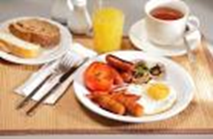

Ai servit………? Have you had..?

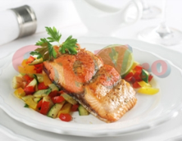
La ce oră servim...................?
What time do we have dinner?

Ce avem la ..................? What are we having for lunch? 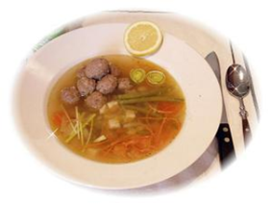 Sunt........... I am starved!
Am făcut un ...................în grădină. We had a barbecue in the back of the garden.
Mi-am pierdut..................... I’ve lost my appetite.

CINE VORBEȘTE? WHO’S TALKING?
THE HOST OR GUEST? GAZDA SAU OASPETELE?
Mâncarea este gata. Vrei sa vii acum? The food is ready.would you like to come through now?
Cu ce să te servesc de băut? What would you like to drink?
Am cumpărat niște vin. I hope red is ok. Dressing?
Unde vrei să mă așez? Where do you want me to sit ?
Servește– te cu salată! Help yourself to some salad.
Plăcinta acesata este delicioasă! This pie is delicious!
Am uitat să ântreb dacă ețti vegetarian. I forgot to ask if you were vegetarian.
Tu ai făcut asta? Did you make this yourself?
Se pare că nu am furculiță . I don’t seem to have a fork!
Cum se numesc acestea? How do you call these?
Nu, mulțumesc! Eu nu sevesc. Not for me , thank you .
Mulțumesc pentru o seară minunată! Thanks for a lovely evening!
Mâncarea a fost minunată ! The food was really lovely.

Puneti propozitiile in ordine: Put the sentences in the logical order:

HOTELS /HOTELURI
I PAID MY BILL AM ACHITAT.
I CHECKED IN AT THE HOTEL. M-AM CAZAT.
I LEFT THE HOTEL. AM PLECAT DE LA HOTEL
I WENT UP TO MY ROOM AM URCAT IN CAMERĂ
I SPENT THE NIGHT IN THE HOTEL. AM PETRECUT NOAPTEA ÎN HOTEL.
I HAD AN EARLY MORNING CALL. AM PRIMIT UN TELEFON MATINAL
I BOOKED THE HOTEL . AM REZERVAT HOTELUL
I WENT TO A LOCAL RESTAURANT FOR DINNER. M-AM DUS LA UN RESTAURANT LOCAL PENTRU CINĂ.
I ARRIVED AT THE HOTEL. AM AJUNS LA HOTEL
I GOT UP AND HAD BREAKFAST. M-AM TREZIT SI AM SERVIT MICUL DEJUN
I TIPPED THE PORTER WHO TOOK MY LUGGAGE TO THE ROOM.
AM DAT BACȘIȘ HAMALULUI SĂ ÎMI DUCĂ BAGAJUL ÎN CAMERĂ.

RESTAURANTS/RESTAURANTE
I HAD THE STARTER. AM SERVIT APERITIVUL
I PAID THE BILL AM ACHITAT
I LEFT THE RESTAURANT . AM PLECAT DE LA RESTAURANT.
I LOOKED AT THE MENU M-AM UITAT ÎN MENIU
I TIPPED THE WAITER. I-AM DAT CHELNERULUI BACȘIȘ
I BOOKED A TABLE. AM REZERVAT O MASĂ
I HAD DESSERT.. AM SERVIT DESERT.
I ORDERED MY MEAL. AM COMANDAT.
AI ARRIVED AT THE RESTAURANT. AM AJUNS LA RESTAURANT.
I HAD MY MAIN COURSE. AM SERVIT FELUL PRINCIPAL.
I LOOKED AT THE WINE LIST. M-AM UITAT LA LISTA CU VINURI

MONEY!!! 1 EURO – 4.44 LEI

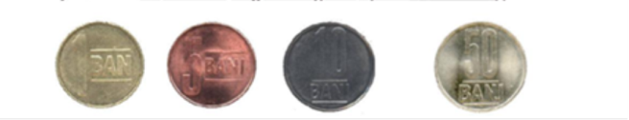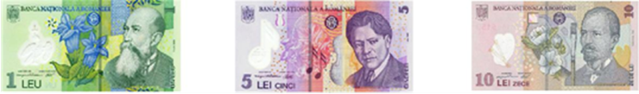
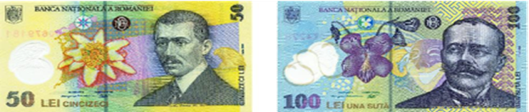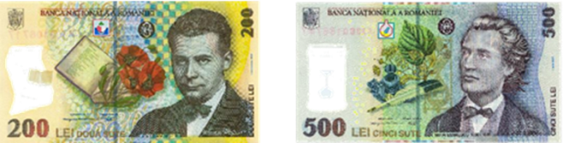

Succes in activitățile proiectului și ședere plăcută!!!!
Good luck in carrying out the project activities! Enjoy your trip to Romania!!!!!

GREETINGS:





