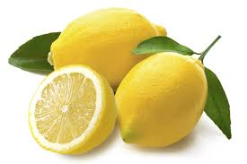LESSON :Talking about food and drinks (English-Italian)
Dictionary (key words) about meals-food and drinks and useful expressions of ordering food and drinks.
TASK 1. Write the correct word under the picture in English and Italian languages.
TASK 2.Classify. Put the food and drinks in the correct place.
TASK 3.Odd out one.
Task 4.Dialogue:ordering food and drinks. Translate the mini-dialogue in Italian language.
Typical Sicilian recipe “Stuffed pastry rolls “in English and in Italian languages

TASK 1- WRITE THE CORRET WORD UNDER THE PICTURE IN ENGLISH AND ITALIAN LANGUAGES
Soup lemon ice cream lemonade carrot pasta eggs watermelon beans orange juice burger tea onion grapes mango eggs
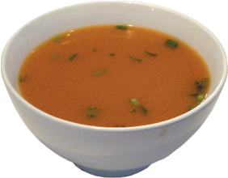

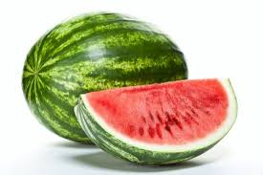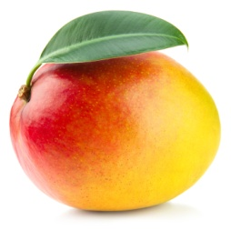

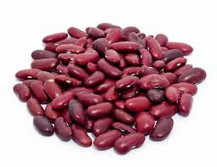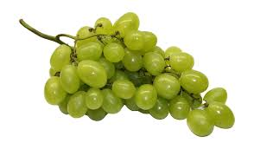

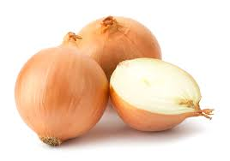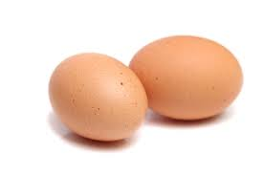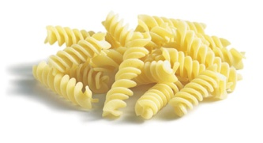

TASK 2 .Put the food and drink in the correct place.
Mela-caffe’-carne-pasta-gelato-uova-pizza-pane-limone-uva-pesca-anguria-patata-pomodoro-zucca-cipolla-acqua-prosciutto-pesce-lattuga-aglio-sformato-patate fritte -te’-latte-coca cola-fungo -ciliegia-fragola-zuppa-torta al cioccolato-finocchio
VEGETABLES  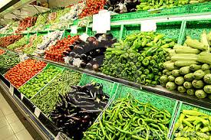 | MEAT  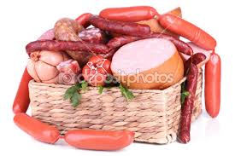 | DRINKS  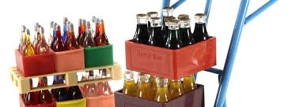 | FRUITS  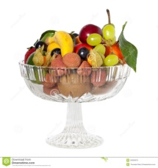 | DIFFERENT FOODS

Task three : circle the odd one out (English)
- Bean Carrot Onion Fried Chips
- Lemon Apple Fish Strawberry
- Pasta Lettuce Meat Sausages
- Orange Biscuits Cake Ice-cream
- Coffe apple tea milk
- Apricot Strawberry Lemon Mushroom
- Spirit Beer Coke Cucumber

Esercizio n.tre : cerchia l’intruso (Italiano)
- Fagiolo Carota Cipolla Patatine Fritte
- Limone Mela Pesce Fragola
- Pasta Lattuga Carne Salsiccia
- Arancia Biscotti Torta Gelato
- Caffe’ mela te’ latte
- Albicocca Fragola Limone Fungo
- Liquore Birra coca cola cetriolo

DIALOGUE 1. ORDERING FOOD AND DRINKS
TRANSLATE THIS MINI –DIALOGUE IN ITALIAN :
A: Can I help you?
A: __________________

B: Yes please. I’d like a cup of coffee.
B:___________________

A: Anything else?
A: __________________

B: No, thanks.

DIALOGUE 2
Translate this mini –dialogue in Italian
A: Hello!
A:____________

B: Would you like something to eat?
B: __________________________

A: Yes please. I’d like some pasta and some fish and chips.
A:____________________________________________

B: Here you are.
B: _____________________

A: Thanks.
A:______________

B: Can I have the bill?
B: _____________________

“CANNOLI”
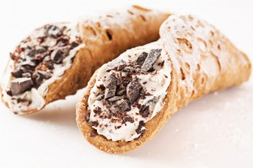
Sono i dolci ormai famosi in tutto il territorio nazionale, costituiti da un involucro (la “scorza”) ed un ripieno di crema di ricotta. Per la “scorza”, preparate a fontana 250gr. di farina bianca, nella quale amalgamerete una chiara di uovo, 1 noce di sugna, 1 cucchiaio di zucchero, 1 cucchiaino di caffè in polvere, 1 di cioccolato amaro, 1 pizzico di sale e tanto vino bianco quanto ne occorre per ottenere una pasta in un tovagliolo. Stendete poi la pasta con il mattarello, ottenendo una sfoglia non molto sottile, dalla quale staccherete dei dischi di diametro di 10 cm. Ungete di sugna gli appositi “cannelli” ( di canna o di latta, lunghi 13 cm. E del diametro di 2 cm.), attorno ai quali avvolgerete i dischi, saldando bene con albume il punto di congiunzione. Friggeteli in olio bollente ( possibilmente in una friggitrice) sino a che, all’interno e all’esterno, abbiamo assunto il caratteristico colore brunito. Scolateli e disponeteli su carta assorbente, togliendo successivamente i “cannelli”. Preparate adesso il ripieno. Passate a setaccio 250 gr. di frutta candita ridotta a dadini e 50 gr. di cioccolato amaro sminuzzato. Quando gli ingredienti si saranno bene amalgamati, riempite le “scorze” già pronte.
STUFFED PASTRY ROLLS
It is a sweet well-known all over our country that consists of a hard outside (the “rind”) and of a filling of “ricotta” cream. To prepare the “rind”, put 250 gms. of white flour on the working-surface, shape it into a mound and make a hole in the centre where you will put 1 eggwhite, 1 knob of lard, 1 tablespoon of sugar, 1 teaspoon of coffee powder, 1 of bitter cocoa, a pinch of salt and enough white wine to get solid dough. After kneading it, let it rest for 1 hour wrapped in a towel. Roll the dough out with the rolling-pin and so as to get a not too thin sheet. Cut many disks 10 cm across out of the sheet, then grease the traditional tools (cane or tin cylinders, 13 cm. Long and 2 cm across) with lard, roll the disks round the cylinders, sealing the joints well with eggwhite. Fry them in hot boiling oil until both inside and outside are brown in colour. Let them drain on an absorbant paper, then slide the cylinders out. To prepare the filling, sieve 250 gms. of “ricotta” cheese and knead it with 150 gms. of sugar, 50 gms. of diced candied fruit and 50 gms. of chopped cooking chocolate. When blended well, stuff the “rinds” with it.

